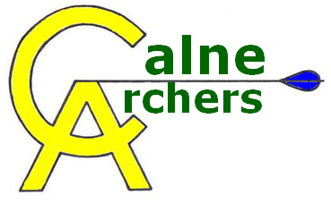 | Code of Conduct of Club Officials and Volunteers
The essence of good ethical conduct and practice is summarised below. All volunteers must:

- Consider the well-being and safety of participants before the development of performance

- Develop an appropriate working relationship with participants, based on mutual trust and respect

- Make sure all activities are appropriate to the age, ability and experience of those taking part

- Promote the positive aspects of the sport (e.g. fair play)

- Display consistently high standards of behaviour and appearance

- Follow all guidelines laid down by the national governing body and the club

- Hold the appropriate, valid qualifications and insurance cover

- Never exert undue influence over participants to obtain personal benefit or reward

- Never condone rule violations, rough play or the use of prohibitive substances

- Encourage participants to value their performances and not just results

- Encourage and guide participants to accept responsibility for their own performance and behaviour.

