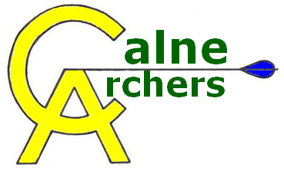 | Line Marshalling Policy

In order to run a safe shooting line, the nominated line marshall on any given day should follow these guidelines:

1) Ensure the Shooting line and waiting area are clearly defined
2) Always use a whistle!
3) Use the following signals:
1 = Commence shooting
2 = Change of Archer (optional)
3 = Retrieve Arrows
Multiple Short Whistles = Hold Fast
4) Always ensure everyone has returned to the waiting line before signalling to retrieve arrows
5) Ensure everyone obeys the following health & safety rules:
a) no running, skippings, etc, on the range
b) appropriate clothing and footwear are always worn
c) arrows are retrieved from the target and the ground safely
d) arrows are carries safely
6) Any full size targets not being used at 50m+ should be used at the 30m-40m range (with 80cm faces) to minimise arrow retrieval time.

The range should always be set up with the shortest distances being shot in the middle of the shooting line, as shown by the below diagram:

