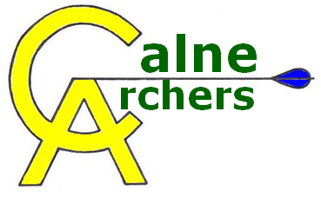 | Health & Safety Guidelines

Archery involves the use of items of equipment that can be extremely dangerous if misused or abused. Please keep in mind the following points.

You must:
- Never point a bow at anyone else, even without an arrow on it.
- Never “dry fire” a bow, (by drawing and releasing it without an arrow).
- You will be taught how to put together a bow correctly, including how to string it safely. Always adhere to the methods taught.
- Only use arrows that are a safe length for you, i.e. your draw length plus 2”
- Obey all whistles – one whistle to start shooting, two rotate the archers at a target and three whistles to stop and collect arrows.
- If you see a hazard such as a person walking behind a target, shout “Hold Fast!”
- If someone shouts “Hold Fast!” (or there are a series of short whistles) stand still and do not release any arrows. Let down the bow in a controlled way, remove the arrow, and wait for instructions.
- Never pull arrows from the target until you have been taught how to do this correctly, and ensure that no-one is standing behind the arrow when you pull it. Always walk up to the side of the target and stand there whilst pulling arrows.
- Always stay behind the waiting line if you are not shooting.
- Only go forward to the shooting line if you are about to shoot.
- Obey all instructions of the Line Marshall at all times.
Also:
- You should set up your archery equipment as neatly as possible behind the waiting line and try to avoid creating any tripping hazards. Please be careful when walking near other equipment.
- When setting up targets, two people should lift bosses onto the target stands.
- Targets should be tethered at all times when shooting outside, except at the Line Marshall’s discretion
- Always wear a bracer and use a finger tab, (unless you are an experienced archer).
- Clothing should not be loose enough to impede string travel or arrow flight.

Anyone deliberately disregarding the above rules may be asked to leave. The above guidelines are designed to be respected in parallel with the Club’s Shooting Rules & Etiquette.

