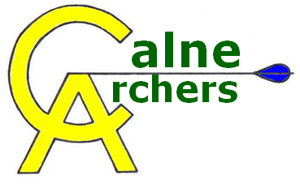 | Annual General Meeting  24th February 2013

- Chairmans Statement
2012-2013 Objectives
- Maintain and grow adult membership.
- Focus on developing junior membership.
- Coaching sessions with qualified guest coaches.
- Dedicated outdoor range.
- Address safety problems with indoor range.

Acknowledgments
- Beversbrook Staff
- Sportivate

2013-2014 Objectives
- Maintain and grow both adult & junior membership.
- Increase classifications & improve handicaps with club.
- Provide coaching within club.
- Dedicated outdoor range.

- Treasurers Report (Statement Accepted)
Summary of Finances
Income: £4,192
Expenditure: £7,011
Accruals: £ 348
Balance: £ 320

Other Expenditure
Making indoor range safe: £100
Donation: Cancer Research UK £200

Sporting England Funds for Junior section
Grant: £2,144
-Courses & Equipment

- Membership Officer’s Report (Statement Accepted)
Club Membership
- March 2012: 22 Adults, 4 Juniors (M 16, F 10)
- February 2013: 31 Adults, 18 Juniors (M 28, F 21
Instructors
- 7 qualified leaders.
- Anyone interested in becoming leader please speak to comittee
Coaching
- Matt Griffiths to attend Coaching Level 1 course when available
Promoting new membership
- 9 booked on March Beginners Lessons
- Continuing with Taster Sessions, Beginners Lessons & Charity / Open Day.

- Proposed Annual Fees (Proposal Accepted)
Adult Fee: £60 per annum
Junior Fee: £30 per annum
Associate Adult Membership: £45 per annum
£2 per shoot (£3 for Associate Members)
Beginner Lessons £40 for 4 lessons ( including a tab & bracer)
Guest Fee set at £2 -passed by majority (£0(5), £2(8), £3(0), Voluntary donation(1))

- Proposal: Club Target Days (Proposal Accepted)
Monthly Shoots
- Will be held 1st Sunday of every month
- A badge will only be awarded for 1st achievment of each level
- Handicap improvement trophy to be awarded at year end
- Club Handicap Competition to be held in August.
- Longer shoots to be considered in future as members continue to improve

- Election of Club Officers
The following Club Officers were elected:

Chairman: Matt Griffiths
Secretary: Vicky Thomas
Treasurer: Shane Bull
Membership Officer: Claire Griffiths
Equipment Officer: Martin Jones
Promotions Officer:
Records Officer: Steve Tugwell
Welfare Officer: Dawn Tugwell

JR Dawson has stepped down as Promotions Officer.

- Club Etiquette
- Target Days – Don’t distract archers on target days
- Arrow Counting – Come back with all the arrows you shot
- Setting Up / Taking down – All hands on deck to set up / take down the range
- Observe Waiting Line – you should only be on shooting line if you are shooting

- AOB
- Shooting group rotation proposed and will undergo a trial on target day

