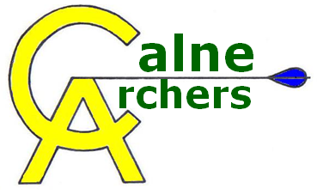 | Annual General Meeting  13th September 2015
The meeting commenced at 1.30pm
26 Members present.
- The Chairman presented his annual report. Membership has been maintained at a similar level to last year and the objectives set for the club have been achieved. He gave an indication of the objectives for the coming year and reminded members they could use the range outside of normal shooting times provided they had undertaken the safety assessment and followed the club policy.
- The Treasurers report was given by the Chairman. He gave a summary of the club’s finances. There were no questions
- The membership currently stands at 54 (32 adults and 22 juniors). There are nine leaders and one coach. There are a number of promotions planned for next year. If any members wish to put themselves forward to train as a leader or coach then they should let the committee know.
- The meeting considered the proposal to keep the annual fee at the same level, namely £99 for adults and £49 for juniors. It was also proposed to drop the limited membership where £2 per session is paid. Finally, it was proposed that beginner lessons would remain at £50 over four weeks.
  - Of those present 25 voted in favour of the above proposals. There were no votes against.
  - A member asked if it would be possible to investigate direct bank transfer for payment of club membership. The Chairman will review that and communicate back to the membership.
- There will be no official target days through the winter although members were reminded they could treat any shoot as a target day provided they had their scores signed off. The Chairman sought to encourage members to set objectives for themselves and reminded them of the Bowman badges in addition to the 252 badges. There will be two handicap competitions run next year.
- The Chairman produced a list of club officers all of whom were standing for re-election. No other member wished to be considered for a club officer position. There is currently a junior officer vacancy and the committee is seeking to fill it. Excluding the current club officers, 16 members voted in favour of re-electing those existing offices and no one voted against.
- The Chairman reminded members of club etiquette in that they should arrive promptly and follow the protocol set out on the website. Anyone who wish to smoke could do so however they should ensure it was away from the waiting area. We have to be mindful of other members and the fact that children were also present.
- There were no additional questions or any other business to deal with save that the Chairman indicated he was canvassing support for an event in a few months’ time where we would have some training on the use of equipment, bow and equipment use and set up and give members the chance to buy sell and swap items. The general consensus was this would be a welcome event.

The meeting ended at 1:50 PM

