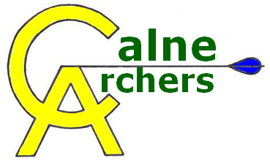 | Annual General Meeting  1 September 2018
The meeting commenced at 1.30pm
8 Members present.
- The Chairman was unwell and unable to attend. The AGM was chaired by Steve Tugwell, Records Officer.
- ST presented the annual report. He reviewed the objectives from last year. Membership has fallen but seems to be at a level which is maintainable. There has been a big take up of 252 awards and this appears to have been a successful initiative. Objectives for the current year 2019/2020 were identified and agreed including maintaining adult and junior membership levels, seeking to develop and coach members as per the new development plans (they are available on the Club website). We will continue to work towards the longer-term objective (target 2028) to fund a covered shooting area.
- The Treasurer, Nev Walters gave a report including a summary of the club finances. The figures on the AGM presentation showed a healthy balance although six new bosses have been ordered at the cost of circa £1,000. We are on target to have a surplus at the end of the financial year. Funds are set aside for equipment and other self-insured costs. We were also seeking to grow a fund for the covered shooting area. There were no questions.
- Membership is currently 24 (21 adults and 3 juniors). A slight decrease in junior members since last year. We have several qualified leaders and if anyone else is interested they should contact the Chairman. One member has just completed the course. We also have a level I coach. Classification levels have improved from last year in line with our objectives. New members are being encouraged through taster sessions, beginner lessons and we plan to have an open day next year. We would like to see a small increase in members – but the membership is primarily people we see shooting regularly now.
- It was proposed to maintain the annual adult members fee (£90) and the junior fee (£45). The cost of lessons will remain at £60 for 4 lessons – with the “new members welcome session” at the end of the course. These fees were agreed unanimously by the members present.
- The Records Officer reiterated that we were going to keep the same structure as last year regarding target days, club handicaps and the 252 scheme. The handicap annual league will continue using both metric or imperial rounds. This seems to suit most members.
- The club committee resigned and offered themselves for the election. No other members wish to be considered for a club position Re-election to the existing roles was agreed and unanimous as set out below:
Chairman | Matthew Griffiths
Secretary | Malcolm Gregory
Treasurer | Nev Walters
Junior Liaison & Welfare Officer | Dawn Tugwell
Equipment Officer | Vacant
Membership Officer | Claire Griffiths
Promotions Officer | Richard Jefferson
Records Officer | Steve Tugwell

The Club will try to identify an equipment officer.
- The Chairman discussed and reminded members about club etiquette including putting up and taking down, start times, the shooting and waiting line protocols and members being able to use the range at any time subject to appropriate health and safety assessments been completed.
- Any other business – Question about continued membership of Archery GB. Given the reduced membership it had previously been decided that it would not be cost effective to end membership due to the value of insurance cover – though this would be under review as/when the membership expands sufficiently.
There were no other questions in the meeting concluded at 1:45pm

