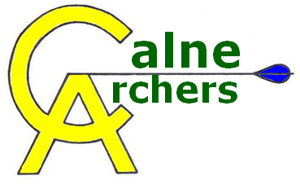 | AGM Report 2021

Chairman’s Report
First of all, let me start by saying that I hope everyone is well and has been keeping safe through what can best be described as an “interesting” past year or so. Now that restrictions are being lifted, we have started to run the club shoots again, and hopefully I will get to see all of you again!
As with last year, whilst Calne and the immediate area have not been in the eye of the storm so to speak, everyone has been impacted to some degree – and the Club has been no different.
As you are all aware, we had to lock down through the last year at times, along with everyone else, and from a Club point of view, as well as the Government guidelines, we are subject to Archery GB’s guidance, and of course Beversbrook’s own decisions. Although the booking system did allow people to get down to the range and shoot at times, it was far from ideal at a Club that has always viewed itself as a one that is as much about the social side as the actual archery.
Now that we are starting to get together again, we are more likely to be on hand to help with anyone that needs assistance or coaching – please let us know if you want any help (whether it is remembering how to string the bow after a long time away, or something a bit more technical!).
We managed to run a Beginners course in July which led to some new members, and we are hoping to run a second course through September – this is a sign that we are starting to get back to normal somewhat, and we can look forward to running taster sessions and further courses in 2022.
As you can imagine, the lack of recent courses has meant that the Club’s finances have taken a minor hit this year (beginner courses are a significant source of funds for us). But we have negotiated a reduced rent for the range which helps, and so we will be keeping the annual fees held for the time being. We have always tried to keep a reasonable amount of cash in the bank to “self-insure” us against unforeseen events, and this means we continue to be in a strong position at the moment.
We have decided to increase the amount we charge for lessons though to cover some of the extra time/costs we will incur. We planned to do this last year, but decided against it given the circumstances, but now things are returning to a form of normality, we will do this for 2022. However, we will off a discount on the first year membership, to help with our next objective…
We have decided to stick with the plan for our 5 year objective to re-grow the club membership. I believe this will be a significant challenge but one that we should attempt – once we can schedule more have a go days and lessons over the next year or so, we can continue working on towards this,
On a different positive note, our new path is now officially open… the ribbon was cut by a member of the Town Council, and this will make our life much easier getting to the range and back once the winter comes in and the rain starts to make the fields boggy. Many thanks to Kevin Whitehorn for organising the necessary grants for this.

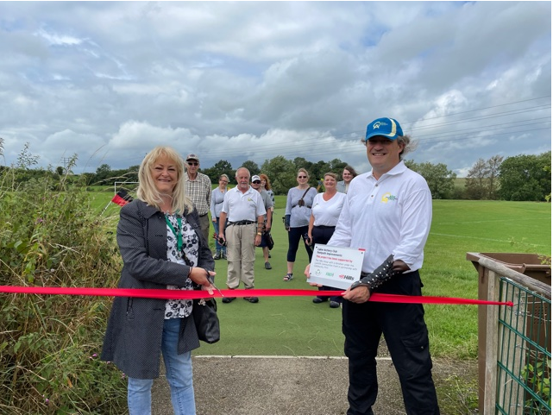

Treasurers’ Report
2020/21 was unsurprisingly impacted by the pandemic, primarily as we had no income from any lessons, and we took the decision to extend memberships. Fortunately we did not need any substantial spending during this period.
The 2020/21 accounts still need to be audited, so the figures in the slides are provisional only.
It is anticipated that 2021/22 will be a better year financially as we start to hold beginner courses, meaning the Club continues to stay in a strong position for now.

Membership Secretaries Report
As the slides show, the membership has held actually grown in the last year as we have had a number of people look to return to the sport as well as some new members from the one course we did manage to run.
Classifications have dropped, but this is hardly a surprise given the lack of shooting for most people.
We will look to hold open days (have-a-go) in Spring 2022, with a Beginners course shortly afterwards.

Proposed Annual Fees
The Committee is proposing to keep the annual membership fees unchanged, but to increase the charge for beginner courses (with a discount on 1st year membership). Please email calnearchers@gmail.com with your vote whether to approve or reject this proposal.

Target Days and Club Competition
We have introduced a new award scheme (the Archery GB Award scheme) to allow people an alternative to the 252 scheme (the new scheme used 80cm targets and a different scoring model). Badges for this will be available as people achieve the different grades.
People can still shoot their rounds and email the scores through to Steve to process. Given the current environment, we’re happy for people to just emails their scores in, without having someone else sign/verify them.

Election of Club Officers
The Committee is standing for election again unchanged. Please send an email to calnearchers@gmail.com to vote either in favour or against.

Club Etiquette
We anticipate the range booking system continuing for the foreseeable future, alongside the Club shoots. This means it is important for people to be aware of the range etiquette. As we start to get larger groups shooting, it is essential that we all pay close attention to the whistles, and ensure we are behind the waiting line when not shooting, etc.
It is vital that people count their arrows and ensure they do not leave an arrow on the range. I cannot stress enough how important this is, especially as the football is starting up again and we are bound to see people running onto the range again. It is essential that we do not leave arrows up on the range.
As mentioned above, we are seeing footballers coming onto the range to collect footballs. Please be aware of this when shooting and make sure you do NOT shoot if anyone is on the range – all normal range rules apply.

AOB/Questions
The Committee try hard to meet what we think are the members requirements (obviously recently this has been a bit harder than usual). But it is only our view. If people have suggestions, questions or ideas, PLEASE let us know.

