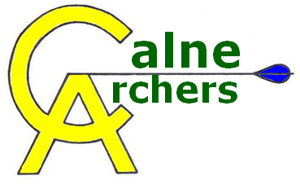 | Beginner Lessons Registration
Name: Date of Birth:
Address (including postcode):

Telephone: home: mobile:
Email address:
Please list below any disabilities, learning or medical conditions which may be relevant to your participation in archery. (This information will be treated in absolute confidence and will only be used by your coaches to determine the most appropriate equipment and teaching styles to suit your personal needs.)

Terms and Conditions
This application form must be completed and signed before starting the course. All medical disclosures relevant to participation in the sport of archery must be indicated at that time.
The stated fee must be paid in full prior to the start of the course. This is non-refundable.
Participants must obey the Club Rules of Shooting and the safety guidelines at all times, and treat the equipment, facilities and coaches with the greatest respect.
Calne Archers and its members cannot take any responsibility for, loss of or damage to, any personal equipment, possessions or vehicle.
All under 18’s attending should be accompanied by their parent/guardian.
Calne Archers are committed to protecting the privacy and security of your personal information. Our privacy policy for lesson participants can be found on our website at this address: http://www.calnearchers.org/wp-content/uploads/Lesson-participant-privacy-policy2020.doc

Participant’s Signature: Date:

If participant is aged under 18, their parent/guardian’s signature is also required…

Parent/Guardian’s Signature: Date:

----------------------------------------------Club Use Only-----------------------------------------------
Date paid: Amount paid: £ cash cheque BACS Received by:

