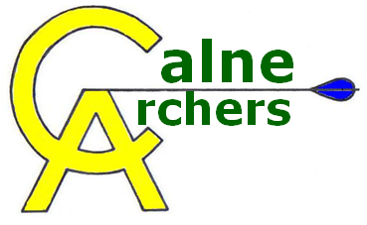 | Lost Arrows

The club runs on a general principle of finding all arrows that have missed the target – arrows should not be left on the range. It is the duty of all archers to find and retrieve this arrows before leaving the range. The only exception to this is if the arrow cannot be found and an emergency/exceptional situation occurs.

An emergencey/exceptional situation will be deemed to have occurred in the following circumstances ONLY:
- It has got too dark to continue looking for an arrow
- A medical situation has arisen requiring the range to be shut

In such a situation the following steps must be taken by the line marshall:

      - Email Notifications
An email must be sent to calnearchers@gmail.com and k.whitehorn@calne.gov.uk stating that the archery range is closed and should not be accessed until further notice.

      - Record Details
A form will be available in the shed which will need to be filled in. This will be used to record the date, details of the arrow lost, what target (lane & distance) was being shot at, and what arrangements have been made to resume the search.

      - Resumed Search
The search should be continued as soon as practically possible (accepting that this may not be the next day).

      - Completed Search
Once the arrow has been successfully located, then the remainder of the form can be filled in and returned to the Chairman. Finally an email must be be sent to calnearchers@gmail.com and k.whitehorn@calne.gov.uk stating that the arrow has been located and access to the range can continue as normal.

Lost Arrow Incident Form
Details of Lost Arrow
Date
Line Marshall
Archer
Distance being shot at
Lane used
Arrow type
Arrangements for renewed search
Notification email sent

Search Details
Date
Line Marshall (who led the search)
Arrow located by
Any lessons learnt/recommendations
Notification email sent

