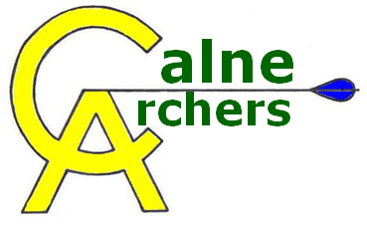 | New Membership Registration
Welcome to Calne Archers.
To ensure our information is correct, please complete and sign this form and return it to Claire Griffiths. We will also use this information to ensure that you are kept informed about club events.
Membership Type (please indicate your choice)
Adult Full (£99) Junior Full (£49)

Name: Date of Birth:
Address (inc. postcode): Gender: Male Female

Telephone: home: mobile:
Email address:

Emergency Contact Please indicate who should be contacted in the event of an incident/accident.
Contact name: Contact tel. no:

Medical Information Please specify any important medical information that our coaches should be aware of (e.g. epilepsy, asthma, diabetes, etc.)

Disability Do you consider yourself to have a disability? Yes No
If yes, what is the nature of your disability?
*Visual impairment *Hearing impairment *Physical disability *Learning disability
*Other (please specify):
Previous Experience
Where did you learn archery? Calne Archers Beginner Lessons
Another club/organisation …if so, where?

Terms and Conditions
This registration form must be completed and signed before membership can commence. All medical disclosures relevant to participation in the sport of archery must be indicated at that time.
The stated membership fee must be paid in full. This is non-refundable.
Participation is at your own risk. Your health and wellbeing should always be a consideration. When returning to archery after an injury, your doctor’s approval should be sought.
Members must obey the Club Rules of Shooting and the safety guidelines at all times, and treat the equipment, facilities and other members with the greatest respect.
Calne Archers and its members cannot take any responsibility for, loss of or damage to, any personal equipment, possessions or vehicle.
The club website contains a password protected Members’ Directory. Please indicate if you wish for your contact details to NOT be added to this? (only members will have access).
Please remove my contact details from the directory □

Signature: Date:

Members under 18 years of age. This form must be checked and signed by your parent/guardian before it is returned.

I agree to my son/daughter/young person in my care participating in the activities of the club.
I understand that in the event of injury or illness, all reasonable steps will be taken to contact me, and to deal with that injury/illness appropriately.

Name of parent/guardian:

Signature: Date:

----------------------------------------------Club Use Only-----------------------------------------------
Date joined:
Amount paid: £ cash cheque
Received by:

